**KPI;**

**1.Total revenue:**

**SELECT SUM(total_price) AS Total_Revenue from pizza_sales;**



**2.Average order value:**

**SELECT SUM(total_price) / COUNT (DISTINCT order_id) AS Avg_Order_Value from pizza_sales**



**3. Total pizza sold:**

**SELECT SUM(quantity) AS total_pizza_sold from pizza_sales**



**4.Average pizzas per order:**

**SELECT CAST(CAST(SUM(quantity) AS decimal(10,2)) /**

**CAST(COUNT(DISTINCT order_id)AS decimal(10,2)) AS decimal(10,2)) AS avg_pizzas_per_order FROM pizza_sales**



**5.Daily Trend:**

**SELECT DATENAME(DW,order_date)as order_day,COUNT (distinct order_id) as Total_orders**

**FROM pizza_sales**

**GROUP BY DATENAME(DW,order_date)**

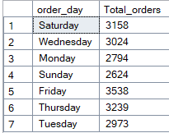

**6.Monthly trend for total order:**

**SELECT DATENAME(MONTH,order_date) AS Month_name, COUNT(DISTINCT order_id) AS Total_Orders FROM pizza_sales**

**GROUP BY DATENAME(MONTH,order_date)**

**ORDER BY Total_Orders DESC**

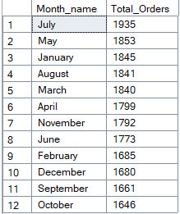

**7.Percentage of pizza sales by category:**

**SELECT pizza_category, SUM(total_price)*100 / (SELECT sum (total_price) FROM pizza_sales) AS sale_by_percentage**

**from pizza_sales AS Total_Sales**

**GROUP BY pizza_category**

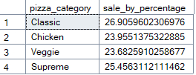

**8.Percentage pizza sales by size:**

**SELECT pizza_size,CAST(sum(total_price)AS decimal(10,2)) as Total_sales ,CAST(sum(total_price) * 100 /**

**(SELECT sum(total_price)from pizza_sales)AS decimal(10,2)) as sales_pizza_percentage_size**

**from pizza_sales**

**WHERE DATEPART (quarter,order_date)=1**

**GROUP BY pizza_size**

**ORDER BY sales_pizza_percentage_size DESC**

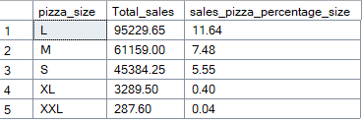

**9.Top 5 best sellers:**

**By Revenue:**

**SELECT TOP 5 pizza_name , SUM(total_price) AS Total_Revenue FROM pizza_sales**

**GROUP BY pizza_name**

**ORDER BY Total_Revenue DESC**

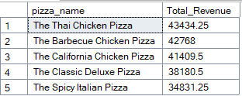

**By Quantity:**

**SELECT TOP 5 pizza_name , SUM(quantity) AS Total_Quantity FROM pizza_sales**

**GROUP BY pizza_name**

**ORDER BY Total_Quantity DESC**

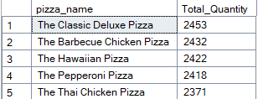

**By Order:**

**SELECT TOP 5 pizza_name , COUNT(DISTINCT order_id) AS Total_Order FROM pizza_sales**

**GROUP BY pizza_name**

**ORDER BY Total_Order DESC**

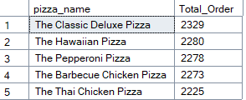

**10.Bottom 5 seller:**

**By Revenue:**

**SELECT TOP 5 pizza_name , SUM(total_price) AS Total_Price FROM pizza_sales**

**GROUP BY pizza_name**

**ORDER BY Total_Price ASC**

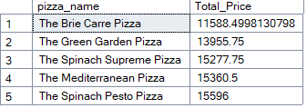

**By Quantity:**

**SELECT TOP 5 pizza_name , SUM(quantity) AS Total_Quantity FROM pizza_sales**

**GROUP BY pizza_name**

**ORDER BY Total_Quantity ASC**

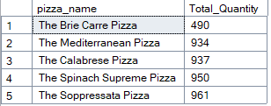

**By Order:**

**SELECT TOP 5 pizza_name , COUNT(DISTINCT order_id) AS Total_Order FROM pizza_sales**

**GROUP BY pizza_name**

**ORDER BY Total_Order ASC**

